This volunteer opportunity will take your skills to the next level. Gain hands-on experience with harvesting, making herbal preparations, and so much more while collecting hours towards your herbal goals! This internship has flexibility based on your personal interests. Make your dreams a reality! Apply today.
​Position Availability:
- March through November.
- Approximately 8-16 hours/month. Approximately 60-100+ hours total.
Benefits:
- Access to plant material to harvest for your own apothecary.
- Attend selected classes for free.
- Discount in the Shoppe.
- Diversify your resume.
- Expand your herbal knowledge.
- Gain hours toward your herbal goals.
- Hands on experience.
- Learn under an herbal expert.
​Requirements:
- 1-3 years of background in herbal medicine knowledge.
- Tincture and oil making experience.
- Preferred, but not required to have completed Home Herbalist Level 1+.
​Jobs may include: Wild crafting, harvesting, making herbal products, herbal gardening, weeding, cleaning up of workspaces, bottling, labeling, tracking inventory, researching, mixing herbal teas, taking photos, marketing, writing herbal articles, transplanting, class presentation(s), assisting with Home Herbalist Level 1 classes, and more.
There is flexibility in tasks if someone has an interest or affinity to one area.
How it works: If you are selected as the 2024 Herbal Intern, each month, a meeting will be held and used as an educational opportunity. Discussion of herbal projects, up to date research, herbal related questions, and other botanical information can be reviewed.
A schedule will be created that works for both parties. Documentation of hours and job descriptions will be required to completed by the intern.

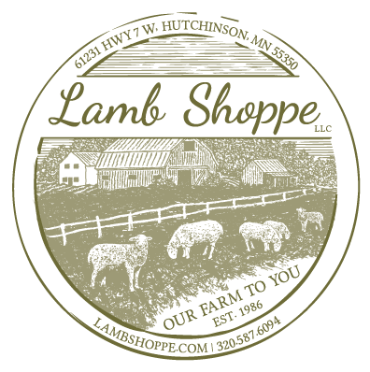
Name:
Address:
Email:
Phone:
Please tell us why you are interested in this internship.

What do you hope to get out of this internship?

Please describe your level of herbal knowledge and herbal training.

Please describe your personal herbal goals and interests.

_________________________________ _______________
Signature Date

- I understand that this is an unpaid, volunteer, educational internship.
- I acknowledge that if I am selected for this internship, I will be responsible for completing the assigned job tasks which are agreed upon starting the internship.
- I understand that this internship will include both independent work and mentorship from Connie Karstens and Clara Osley.

